Department of Education

Student Information Exchange System (SIES)
SIES Web Service

October 15, 2010

Abner García
Technical Leader

www.Intelutions.net

Change Control

Versión |  | Día |  | Autor |  | Descripción
1.0 | Oct/15/2010 |  | Abner García |  | Document Created

Reviewers

Name | Version Approved |  | Position | Date
Yolanda Rodríguez |  | 1.0 | Project Manager
Vicente Graulau |  | 1.0 | SIE Administrator

Table of Content

Change Control 2
Reviewers 3
Student Information Exchange System (SIES) XML Messages 5
1.1 SIES Web Service Overview 5
SIES Web Service IP Address Restriction 9
SIES Web Service Application’s Access 12
1.2 Add Application 12
1.3 Edit Application 14
1.4 Delete Application 16

Student Information Exchange System (SIES)
XML Messages

The Student Information Exchange System (SIES) XML Messages enable the communication between the systems in the Department of Education and the SIE (“Sistema de Información del Estudiante”) System. These messages serve the main purpose of the communication and exchange of the student information data between the systems in the Department of Education. The sections below describe the contents of each one of such message types.
  - SIES Web Service Overview
In the Department of Education resides the SIES Web Service that provides the functionality of search to find the student demographic detail information and return it to the application that requested the information. The search is processed against the production system SIE, which is the primary source system. SIES Web Service functions as a communication layer against the SIE system.
Since the availability of the SIES Web Service is highly required it has two alternative processes to get student information. The primary source is the SIE application database that is hosted in an Oracle server, if for any reason the primary source is not available; it will run a second look up process against a local copy of the SIE data, which is stored in a SQL Server 2008 R2 with the most recent information since the last database update process. The database update process is expected to run in a daily basis.

This is the SIES Web Service workflow process:
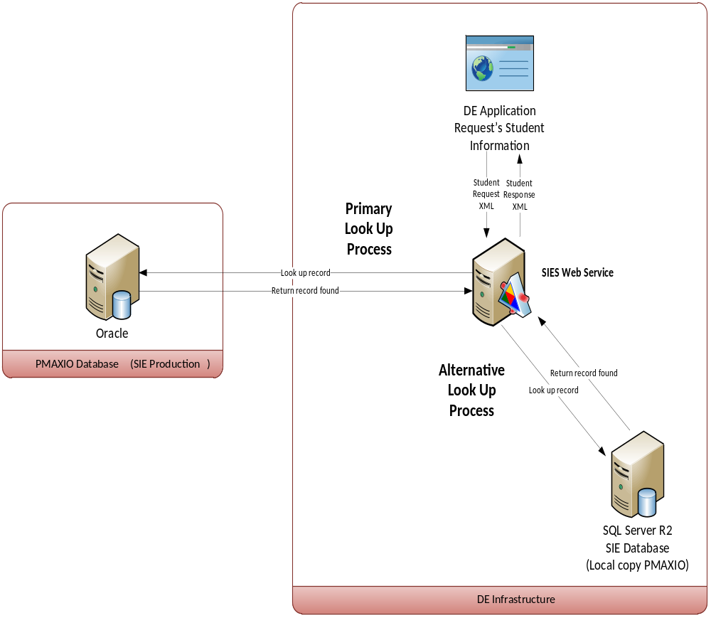

SIES Web Service database update process:

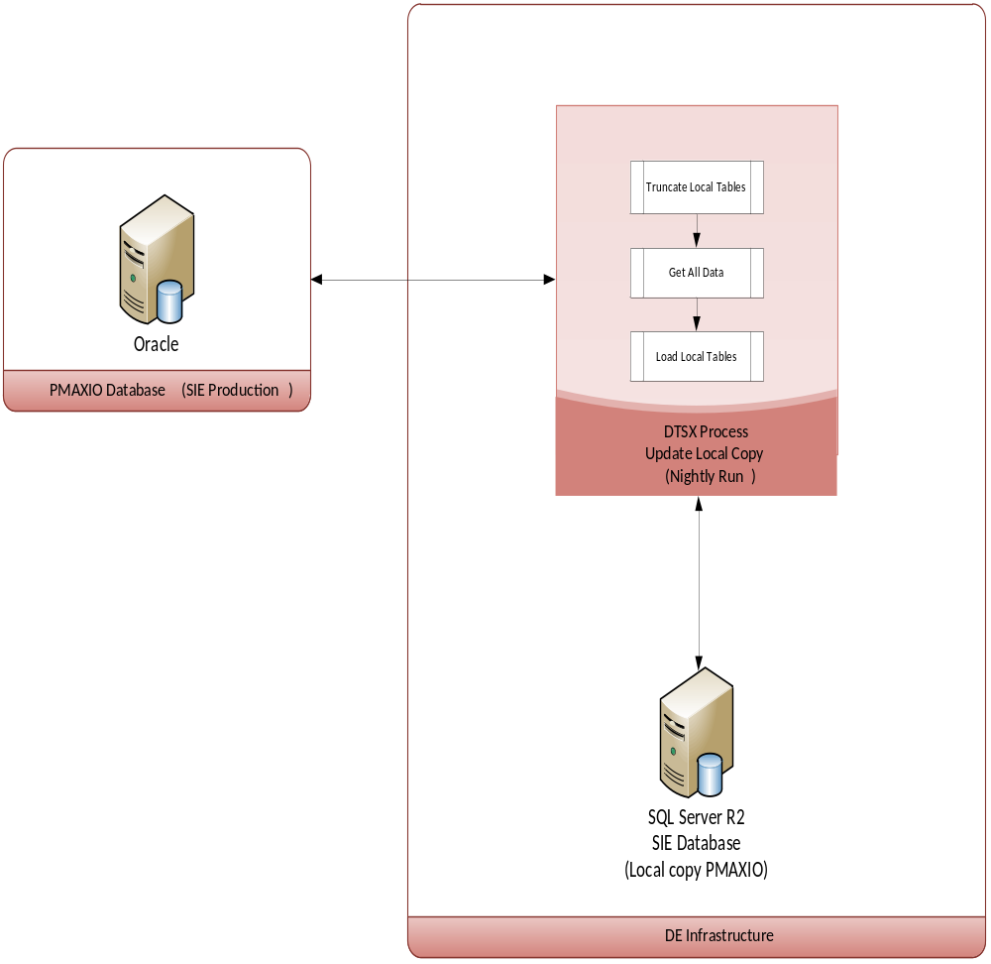

SIES Web Service security uses two methods to validate each application prior it requests student information details.

- First method is validated through the IIS granted IP address allowed for accessing the web service.
- Second method checks if the Application Code, parameter required in the Request XML message, is a valid record in the SIE database table Application.
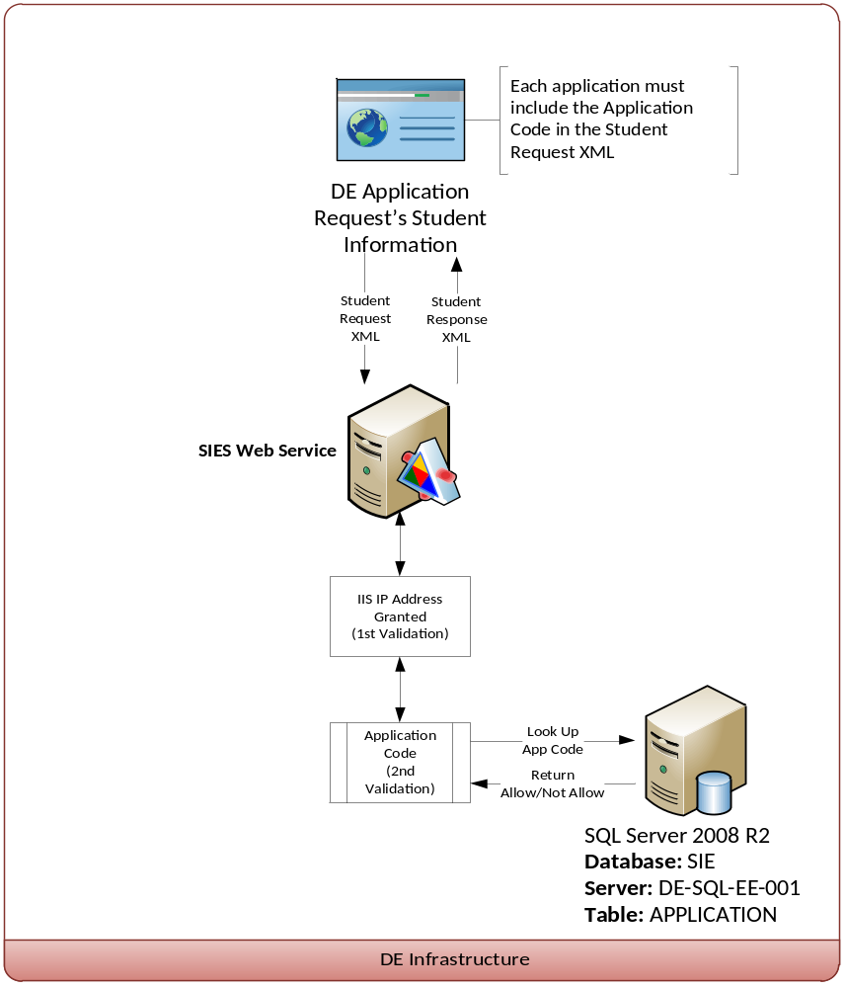

SIES Web Service IP Address Restriction

The SIE Web Service application includes a security validation by IP. By default the SIE Web Service has deny all restriction only allowing the specified IP’s in the server configuration. This is managed and configured in the IIS of the server DE-WEB-EE-001. Admin rights are required to execute these tasks.
- Open de Remote Desktop Client on your computer.
- Enter the IP or Server name and click connect, in this case is DE-WEB-EE-001 or 192.168.22.245.
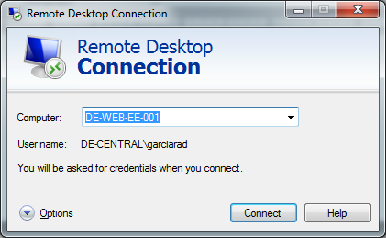
- Click Start -> Administrative Tools -> Internet Information Services (IIS) Manager
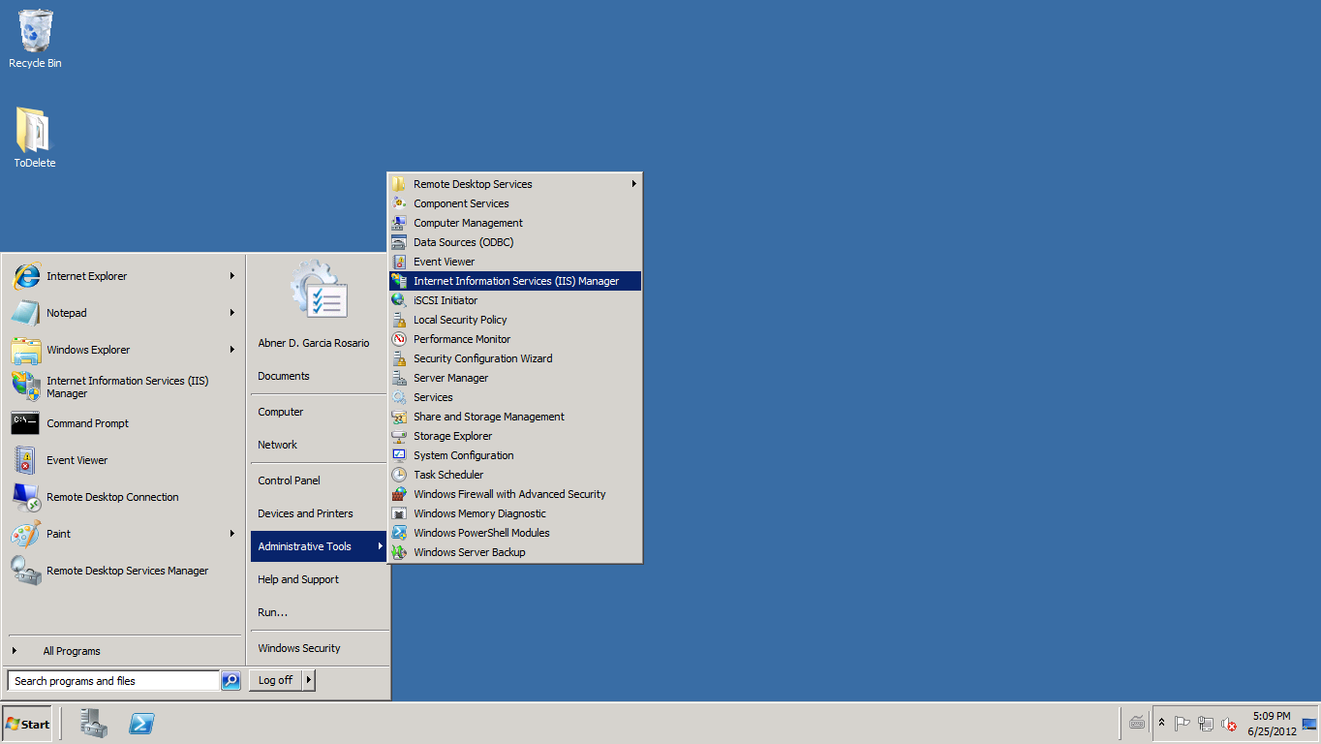
Open the Default Web site and go to the SIEWS web application.
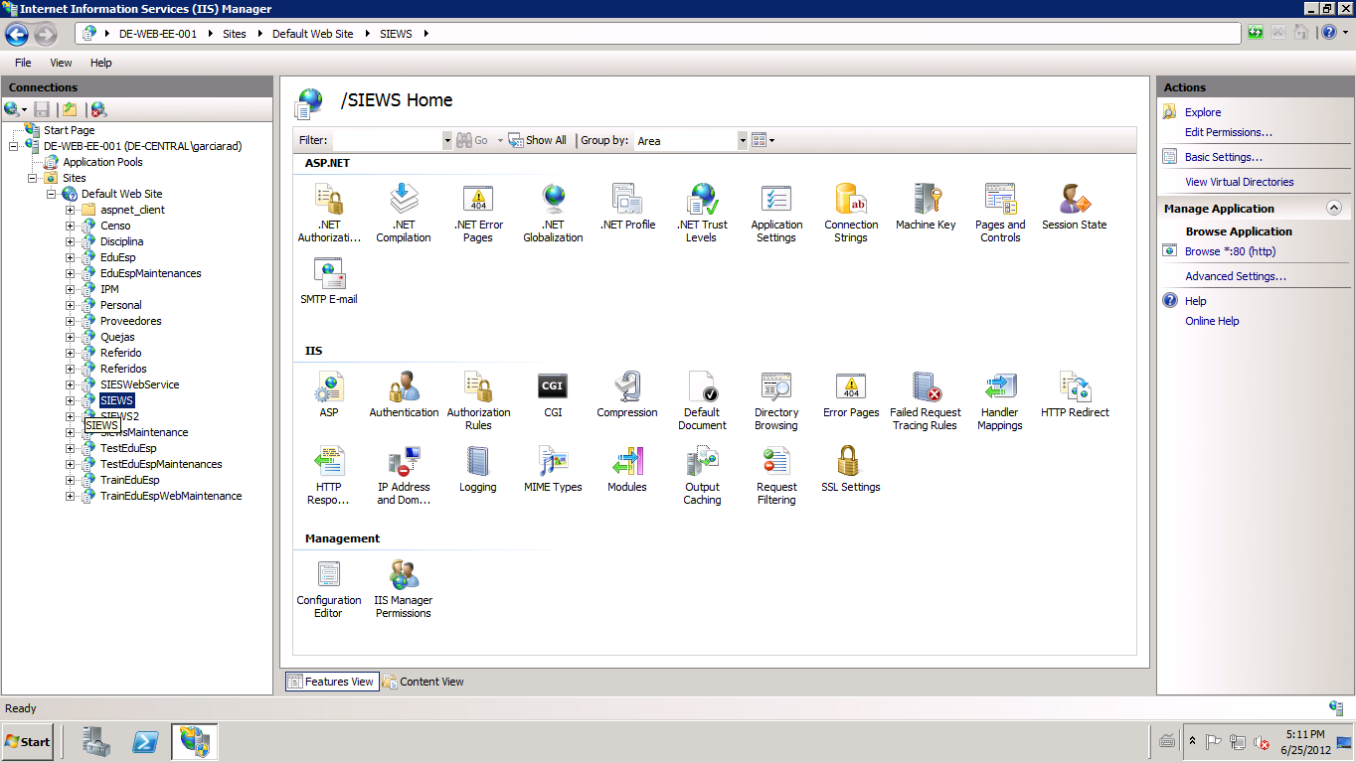
- To the right pane on the same window go to the “IP Address and Domain Restrictions” and double click it to open the feature.
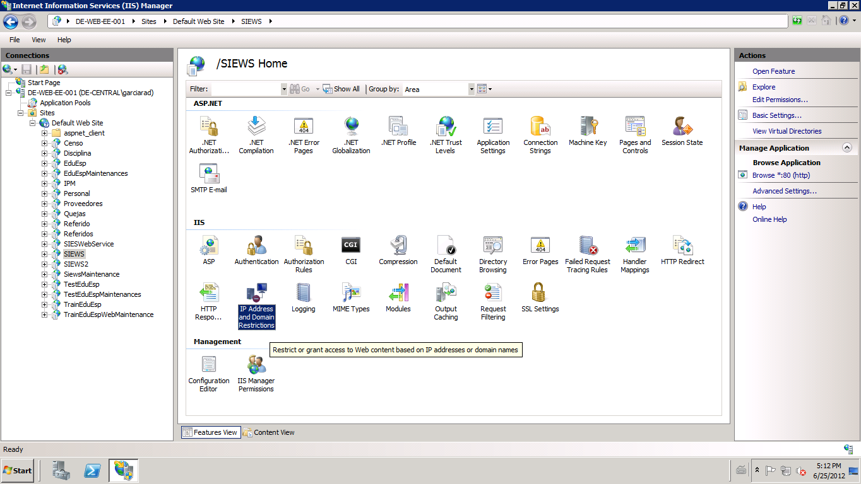

- Go the Actions pane on the top-right part of the window and click Add Allow Entry:
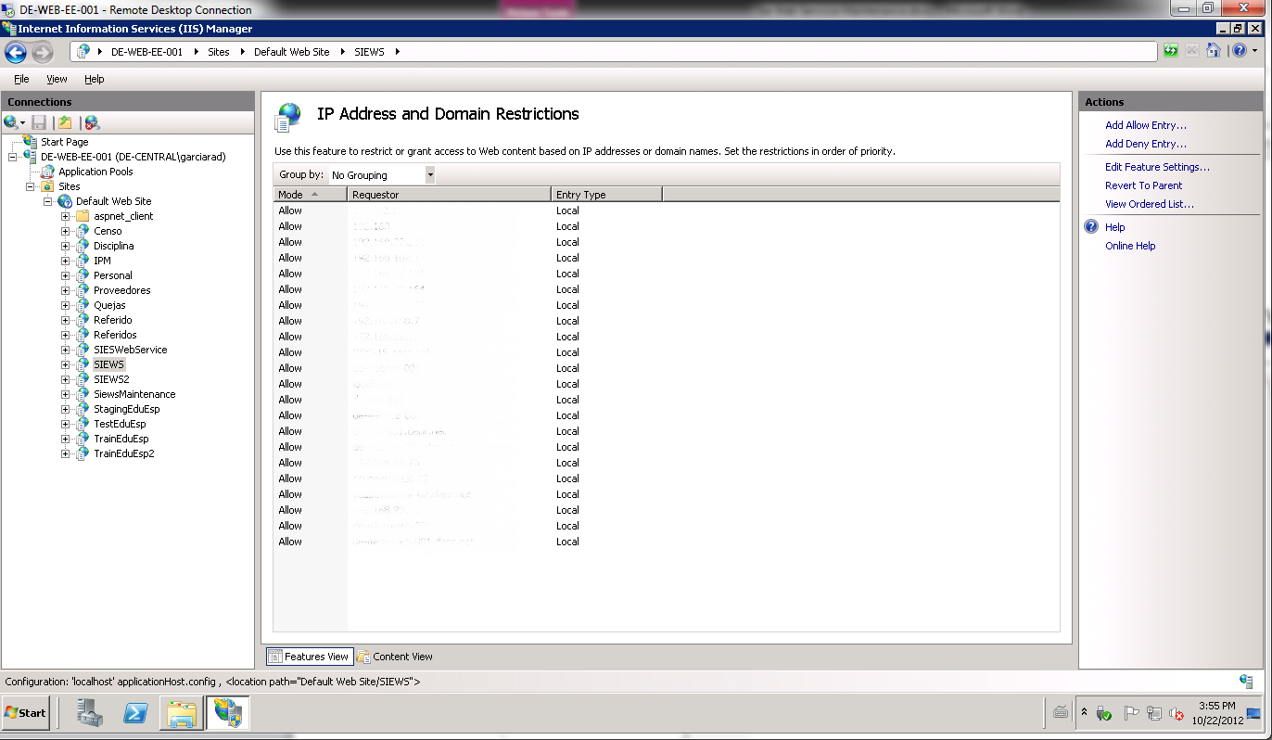
- Enter IP address or domain name and then click OK.
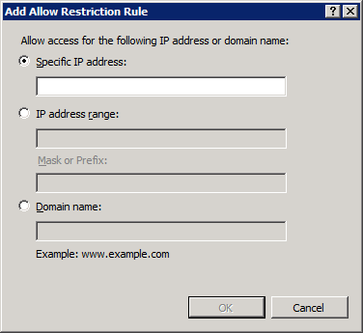
- Now the allow rule for the IP is created. To add more rules just repeat steps 5-7 as needed.
- Once completed LOG-OFF from the server.
- Done

SIES Web Service Application’s Access

This web application maintains the information for each application that has access to the SIE Web Service. In this web maintenance you can add, edit and delete the different application codes.
  - Add Application
- Open the IE 9 (or above) explorer browser and go to the following URL: http://de-web-ee-001/siewsmaintenance/
- The web application will ask for your credentials:
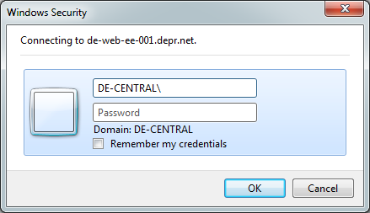
You need to enter your domain user account and password.
- Once the main page loads you will see the actual application codes available on the system.
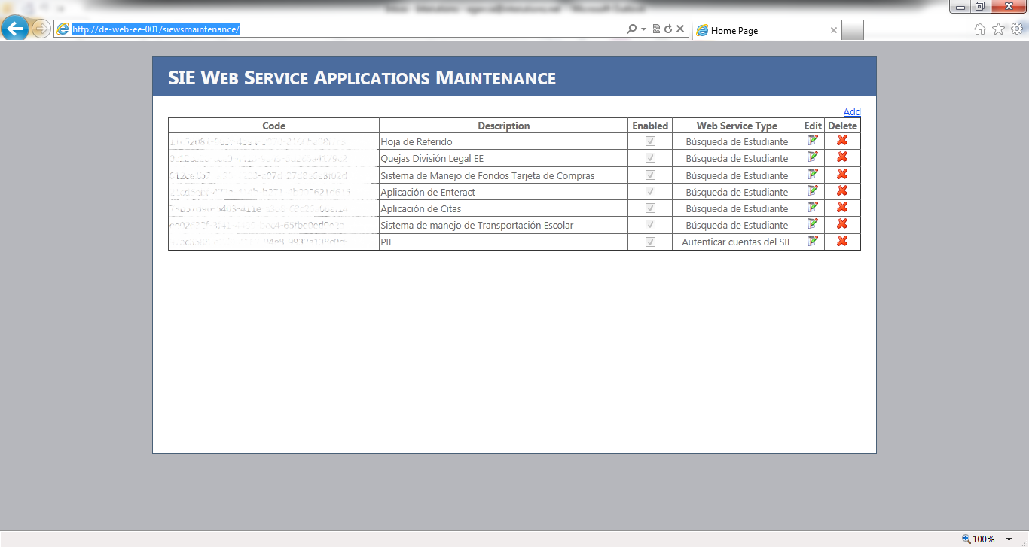
- Click the Add link on the right corner of the web page.
- Enter the name of the Application on the Description Field and select the Web Service Type application. Then click Save link.
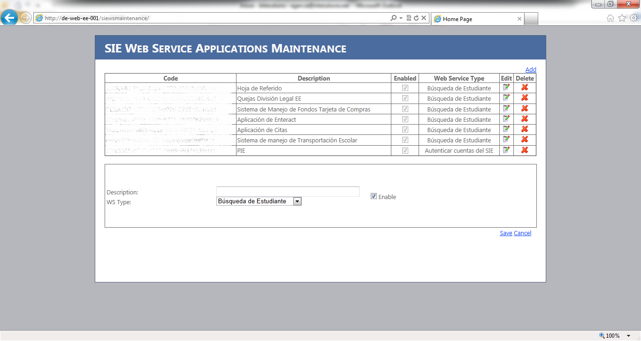
- Then you should see the record created with NEW application code. NOTE: on each addition a NEW code will be generated.
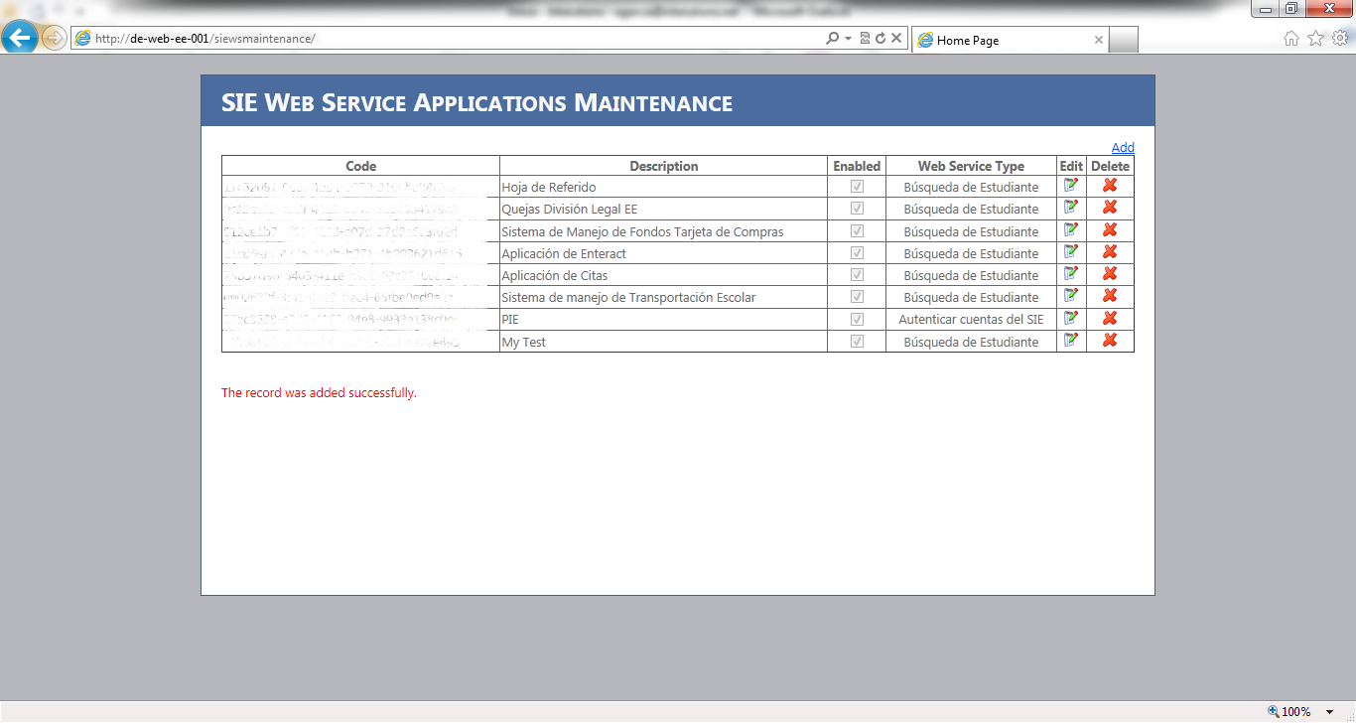
- Done

  - Edit Application
- Open the IE 9 (or above) explorer browser and go to the following URL: http://de-web-ee-001/siewsmaintenance/
- The web application will ask for your credentials:
You need to enter your domain user account and password.
- Once the main page loads you will see the actual application codes available on the system.
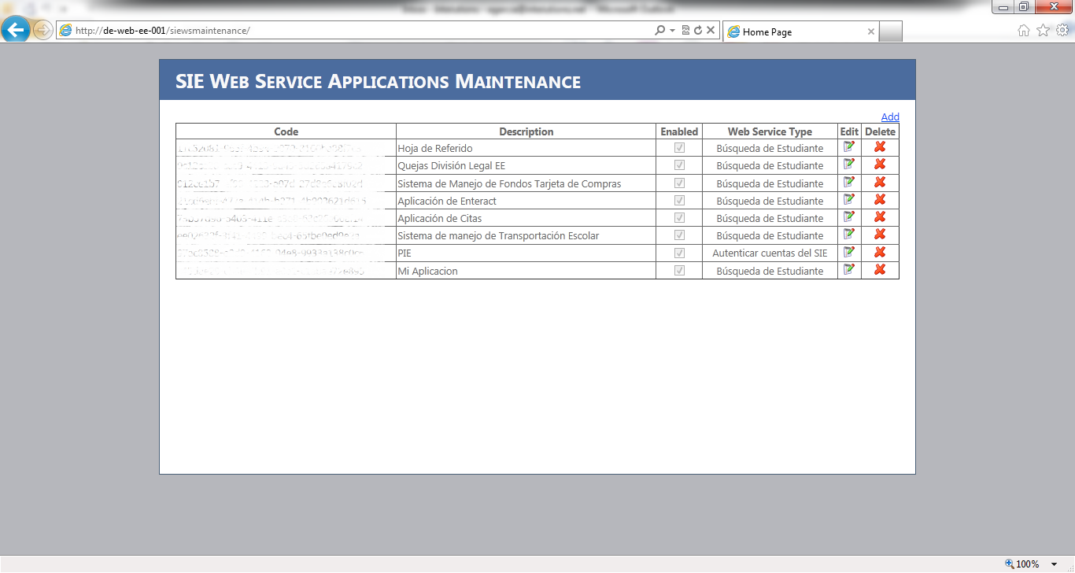
- Click on the edit button on the desired record.

- The edit pane will appear with the information of the record you want to edit. Once changed click the Save link.
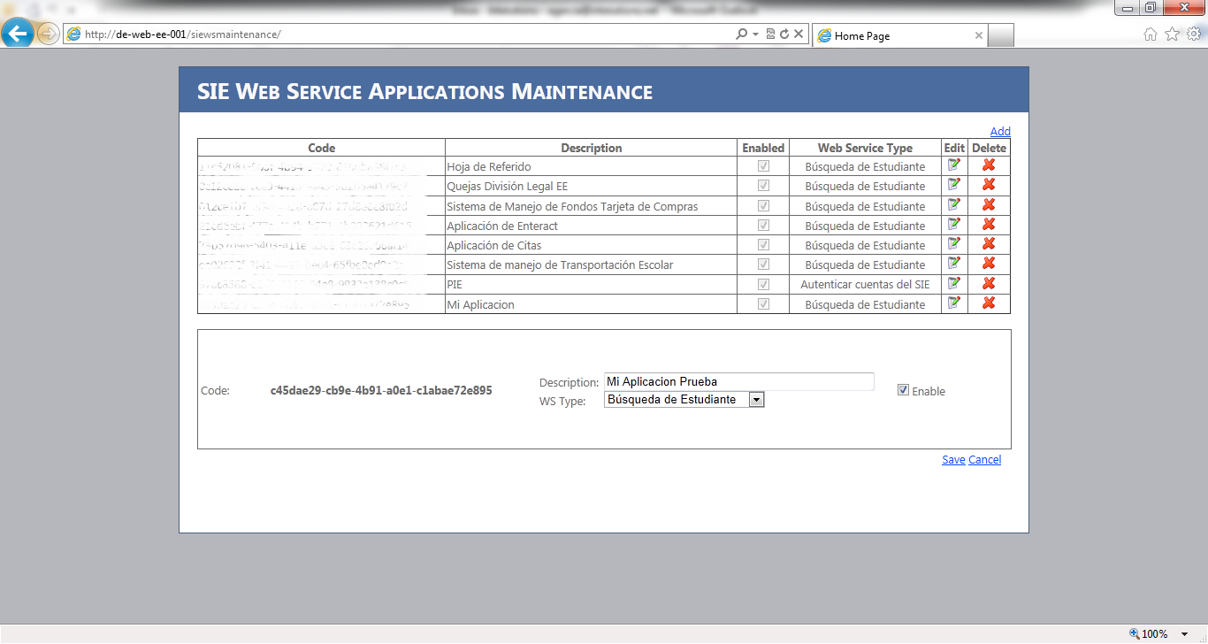
- Done
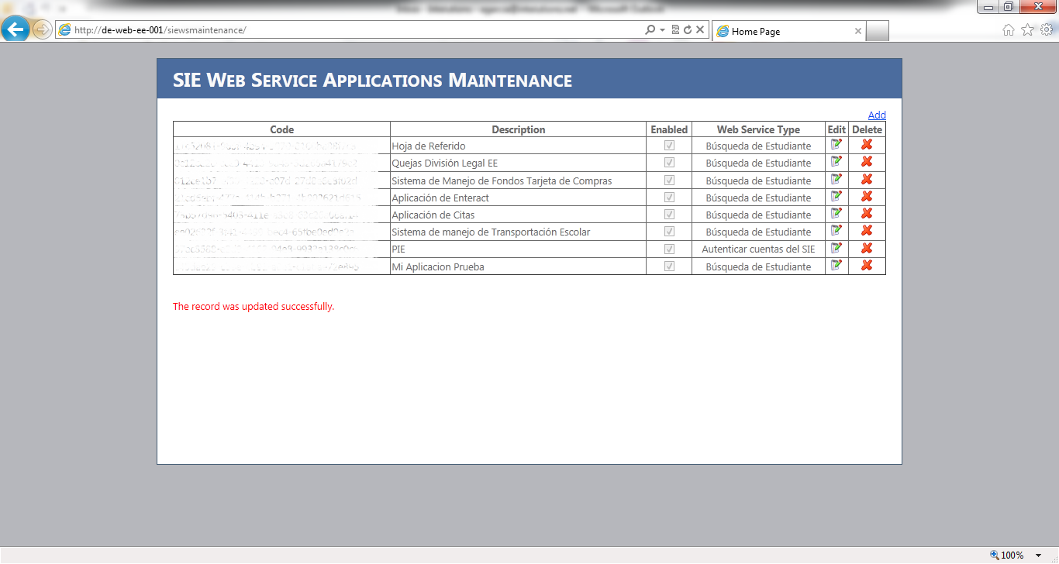

  - Delete Application
- Open the IE 9 (or above) explorer browser and go to the following URL: http://de-web-ee-001/siewsmaintenance/
- The web application will ask for your credentials:
You need to enter your domain user account and password.
- Once the main page loads you will see the actual application codes available on the system.
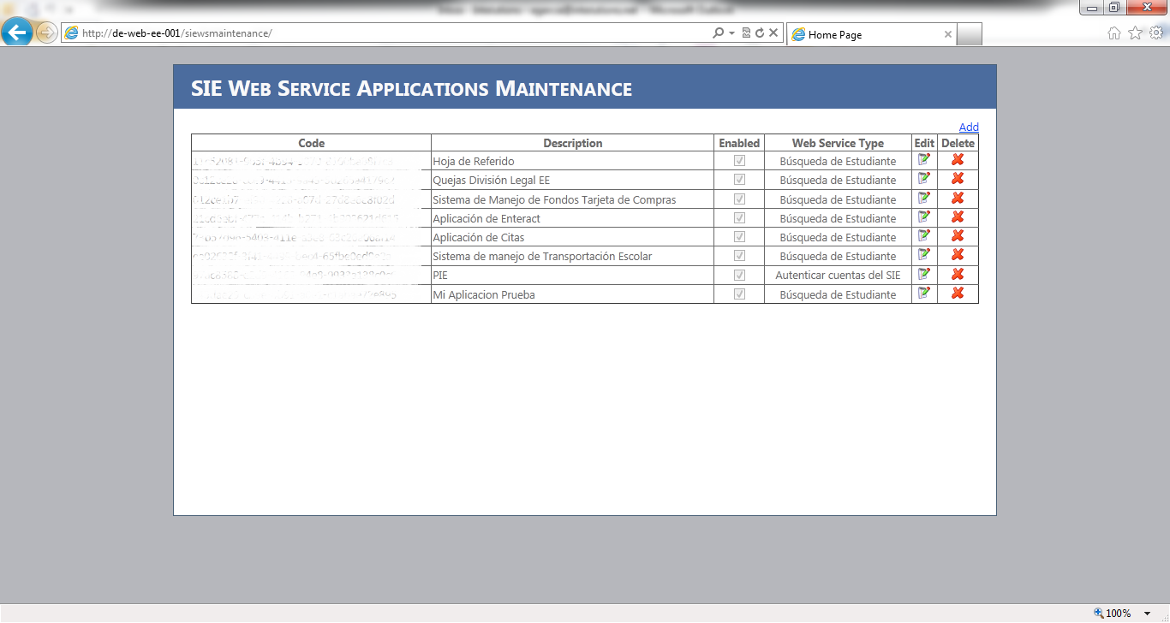

- Click on the delete button on the desired record.

- Final question will appear to challenge the record deletion.
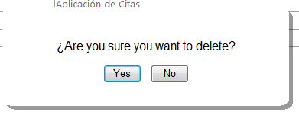
Once you click the Yes button the record will be deleted from the database.
- You should see that the eliminated from the application maintenance page.
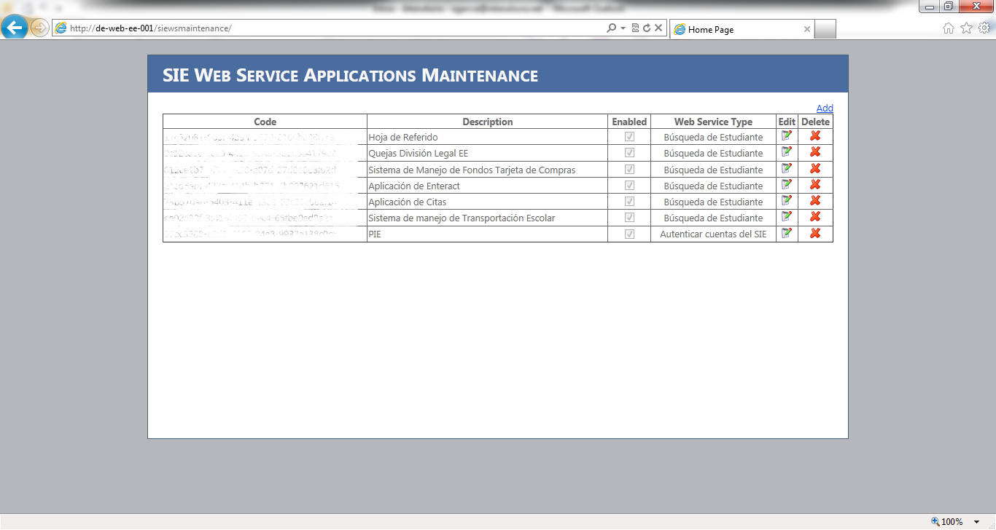
- Done

